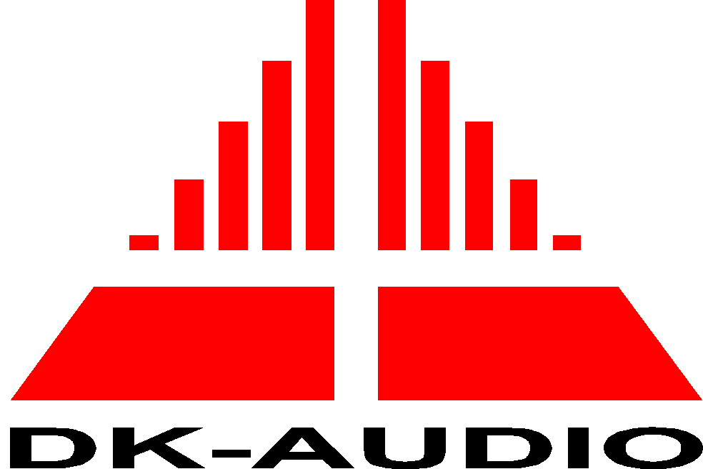


EC Declaration of Conformity
In accordance with EN 45014

We: DK-Audio

of Marielundvej 37D – 2730 Herlev - Denmark

declare under our sole responsibility that the product

Equipment type Compact Varitime Sync Generator
Model name PT5201

Serial number

to which this declaration relates is in conformity with the following standard(s) or other normative document(s)

IEC 61010-1 / EN61010-1 : 2001 (^{2nd} edition) Safety Requirements

EN 55103-1/1996 (Emission)

EN 55103-2/1996 (Immunity)

EN61000-3-2/1995 (Harmonics)

EN61000-3-3/1995 (Voltage fluctuations)

in accordance to the following Directives:

73/23/EEC Low Voltage Directive (and its amending directives)

89/336/EEC Electromagnetic Compatibility Directive (and its amending directives)

Signed by:

Name: Karsten Hansen

Position: CEO

Done at: Marielundvej 37

on: Date:

